Let's get Guelph on the map! 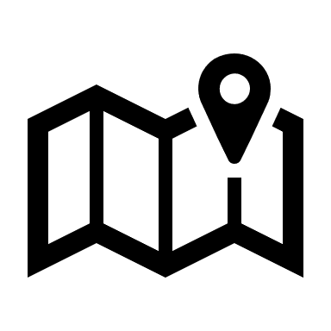
Explore accessibility with the GBFC, AccessNow, and Art Not Shame!

Join the GBFC for an AccessNow MapMission
A MapMission invites you to explore local places and use the AccessNow app to rate their accessibility. It’s a fun way to learn, connect, and make a real impact by helping build a global map of accessible places.

Thursday, September 18, 2025
1:00pm - 3:00pm
at Art Not Shame
119 Wyndham St N, Guelph, N1H 4E9

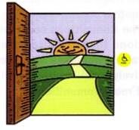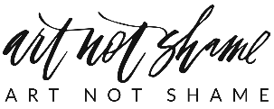
Registration is encouraged but not required, scan the QR code below or visit:
guelphbarrierfreecommittee.org
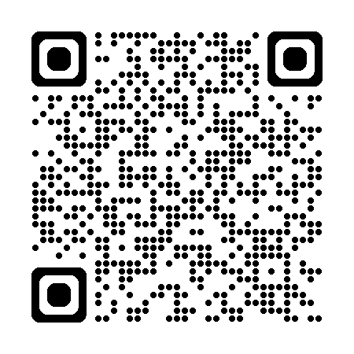

Hosted by the Guelph Barrier Free Committee in partnership with
Art Not Shame
519-822-1260 ext: 3536
barrierfreecommittee.guelph@gmail.com

